**Report homework week1**

After do the step from slide 11 to 17 the result is “Rootp should be corrected to initialize it by 0”, we continue compile code and get core again:

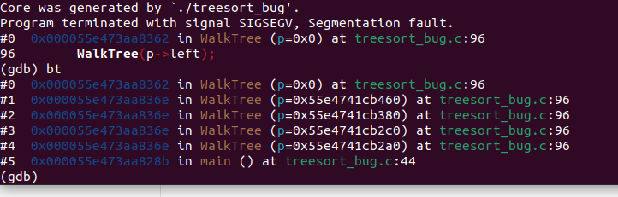

Bug in function WalkTree, we see that #0 when pointer is NULL the function still run so cause the Errol.

Fix that check pointer != NULL. Then continue compile:

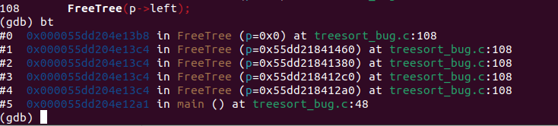

Bug in function FreeTree similar to WalkTree we need to check NULL.